IT24100642

Lab 07Exercise

01.

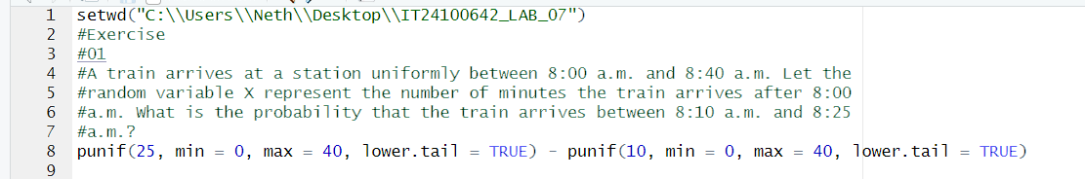

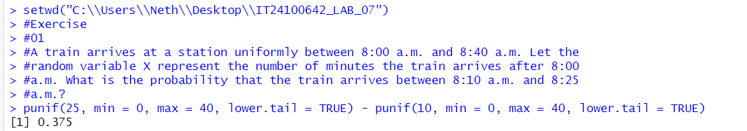

02.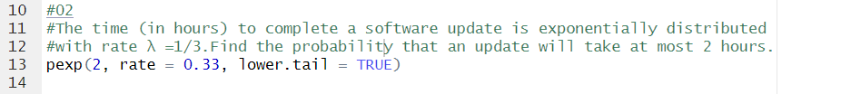

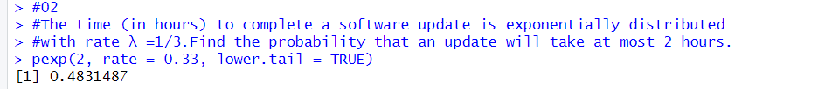

03.

